1. **Date of Birth (Days) Counter Using JavaScript**

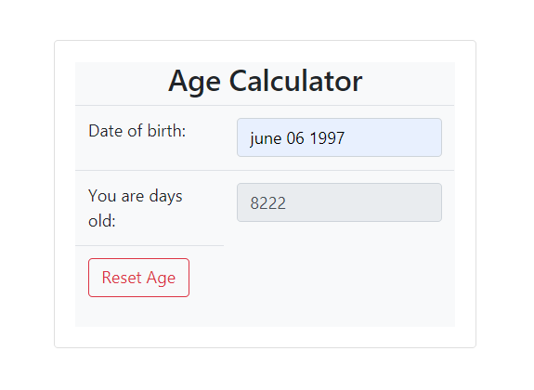

You have now created a date counter that counts days between the date today and the date you entered.

**2. Number Guessing Game**

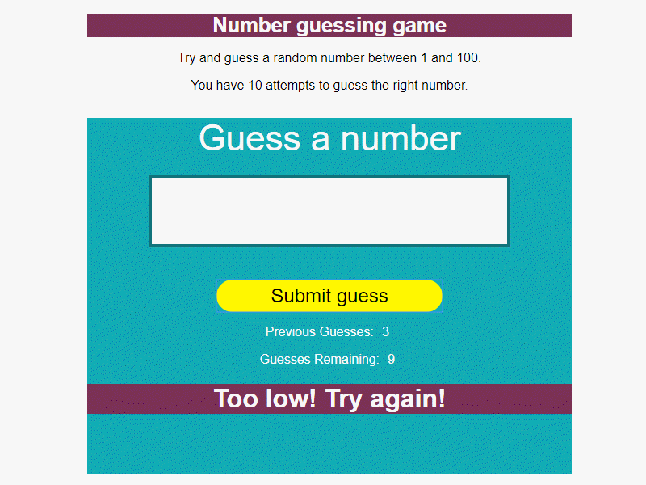

This JavaScript number guessing game project's objective is to code a game where the user must guess a randomly generated number from 1 to 100.

JavaScript Used

* Math.random()
* DOM manipulations
* arrays
* functions
* conditionals

**3. RSS Feed Reader**

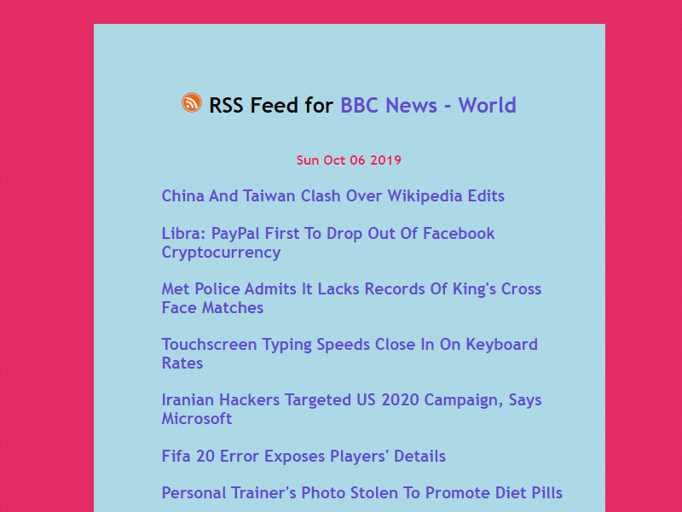

This JavaScript feed reader project's objective is to grab an RSS feed from BBC News or another feed and then display it on your web page.

JavaScript Used

* addEventListener()
* fetchAPI()
* Date()

**4. Drum Kit**

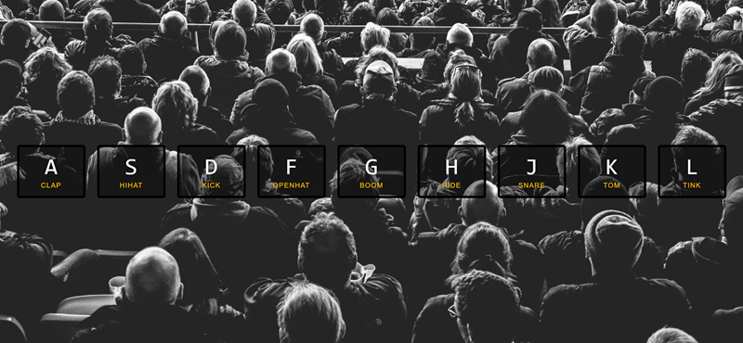

The point of this project is to have each key, when pressed, make a corresponding drum noise. It also uses CSS transitions and animations to make the project more interactive to the user.

JavaScript Used

* DOM Manipulation
* Control Structures
* HTML Audio API
* JavaScript CSS Manipulation
* addEventListener

**5. Simple Examination Application Using HTML JavaScript**

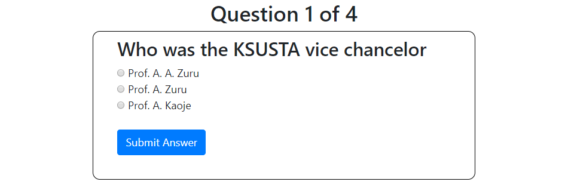

This is a simple examination application using multidimensional array in JavaScript; this is just computer based test CBT but is a prototype.